PROJECT DESIGN PHASE-ll
Data Flow Diagram & User Stories

Date | 29 September 2026
Team No. | 07
Team ID | SWTID-2026-3513
Project Name | AI WeatherWise – AI-Powered Weather Information and Recommendation System
Team Leader | NUVERA HASEEN A
Team Members | JASHVANTHI A, RINOSHA BEEVI P, DEEPIKA J

Solution Architecture:
Solution architecture describes how the different components of AI WeatherWise work together to provide weather information and AI-based recommendations. The architecture connects the application requirements with the backend technologies used in the project.
- Provide weather information for a requested location through REST APIs.
- Provide secure user registration and login using JWT authentication.
- Store user information in MongoDB Atlas.
- Retrieve weather information from an external Weather API.
- Process weather information and generate an AI-based recommendation.
- Organize the backend using routes, controllers, models, middleware and services.
- Provide structured JSON responses through the backend APIs.
- Test and verify the APIs using Thunder Client in Visual Studio Code.

Example – Solution Architecture Diagram:
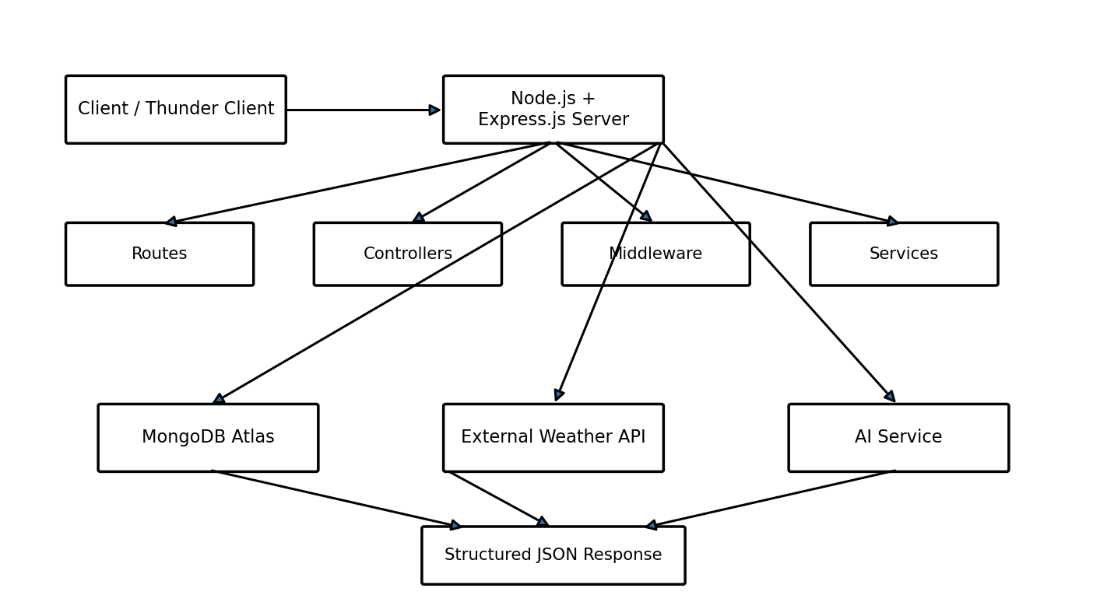
Figure 4.1 – Solution Architecture and Data Flow of AI WeatherWise

Architecture Components
1. Client / Thunder Client
Thunder Client inside Visual Studio Code is used as the client for testing the backend REST APIs. It sends HTTP requests and displays the JSON responses returned by the server.
2. Node.js and Express.js Backend
The main backend server is developed using Node.js with Express.js. It receives HTTP requests, processes them through routes and controllers, and communicates with the required database or external services.
3. Routes
Routes define the API endpoints available in the system, including user registration, user login, weather condition retrieval and AI weather recommendation.
4. Controllers
Controllers handle incoming API requests and coordinate the required processing with models and services to produce the appropriate response.
5. Authentication and Middleware
JWT authentication is used for registration and login. During login, credentials are verified and a JWT token is returned after successful authentication. bcryptjs is used for password security.
6. MongoDB Atlas
MongoDB Atlas is used as the cloud database. Mongoose is used to connect the backend with MongoDB Atlas and manage database interaction.
7. External Weather API
The Weather Module communicates with an external Weather API to retrieve weather information for a requested location, including temperature, humidity, wind speed and weather condition.
8. AI Service
The AI Recommendation Module receives weather-related information and generates an AI-based weather recommendation or summary.

Authentication Flow
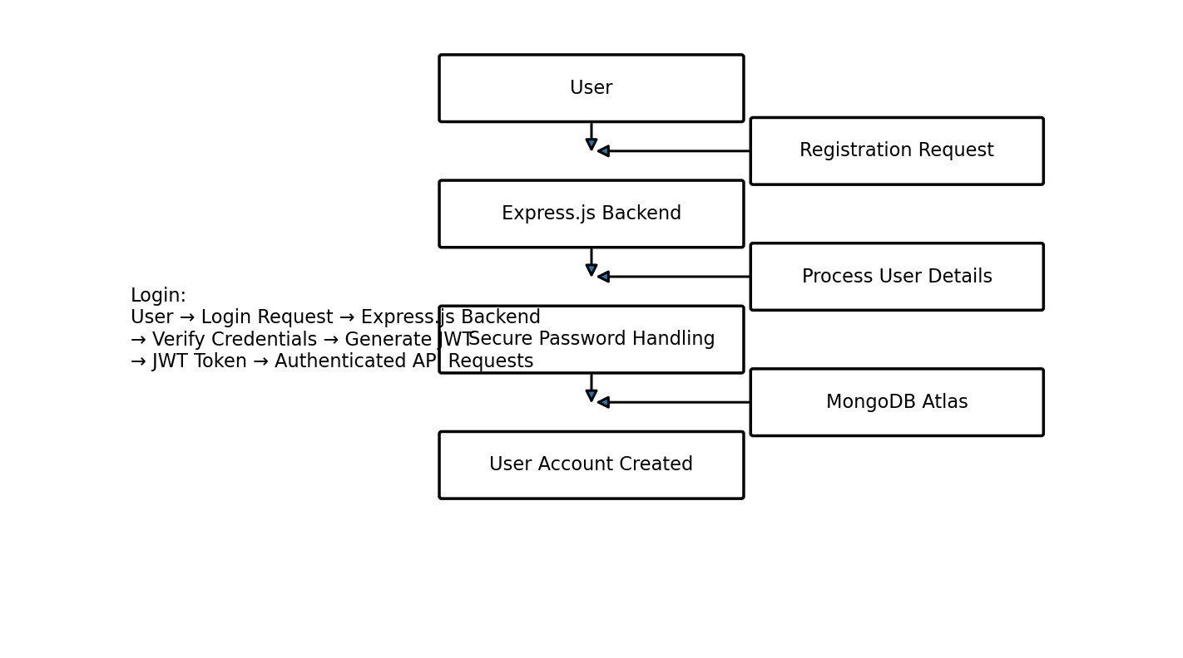
Figure 4.2 – Authentication Flow of AI WeatherWise

Weather API Flow
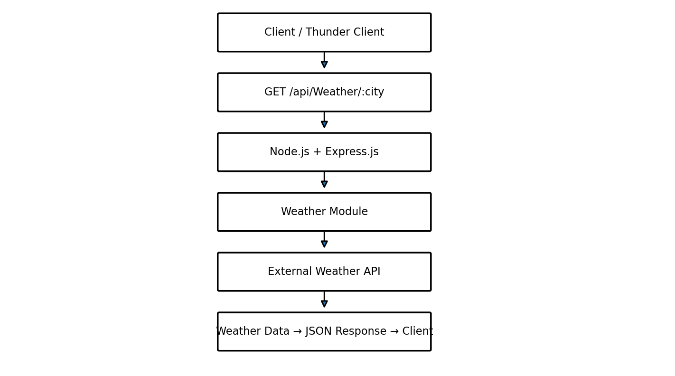
Figure 4.3 – Weather Information API Flow

AI Recommendation Flow
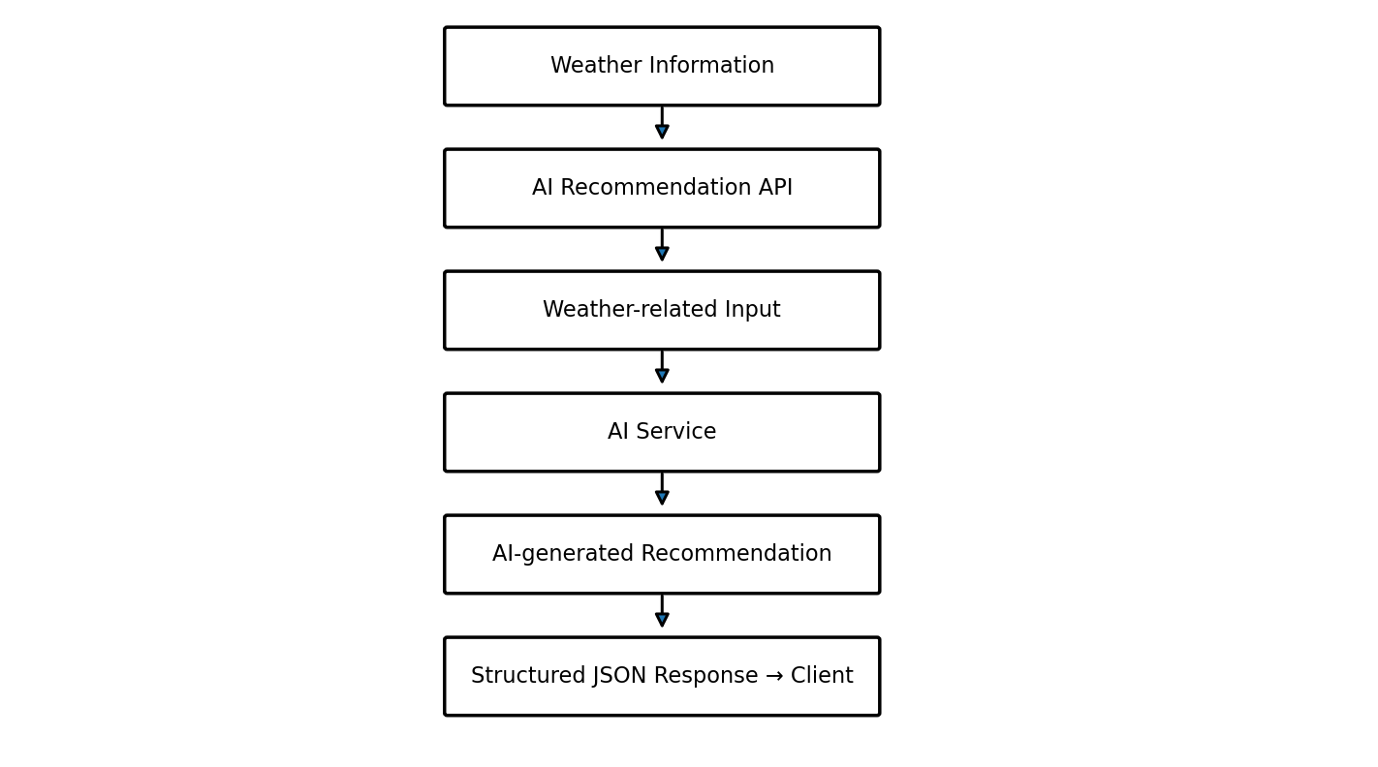
Figure 4.4 – AI Weather Recommendation Flow

Database Interaction
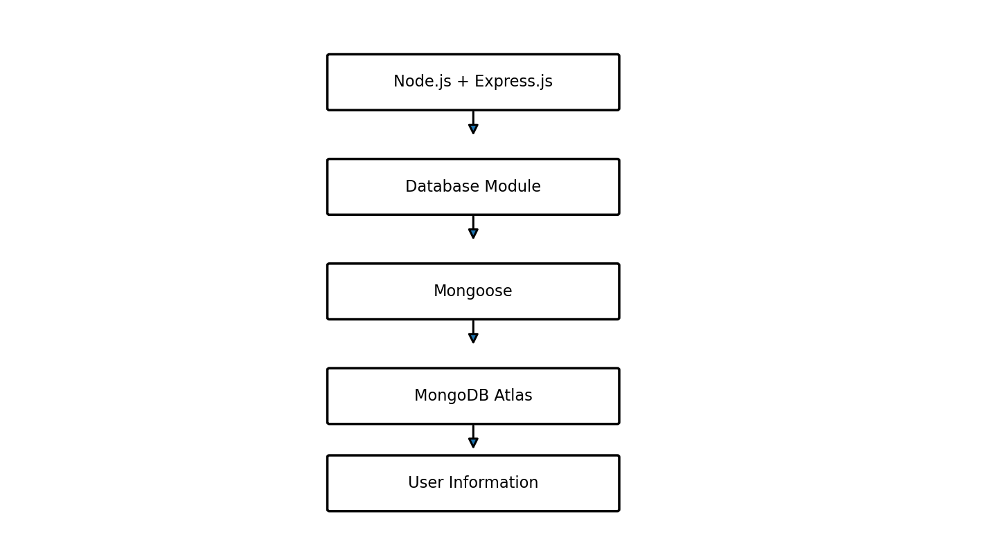
Figure 4.5 – MongoDB Atlas Database Interaction

Backend Folder Structure
Backend/
├── src/
│ ├── config/
│ ├── controllers/
│ ├── models/
│ ├── middleware/
│ ├── routes/
│ ├── services/
│ ├── app.js
│ └── server.js
├── package.json
└── .env
The backend is separated into configuration, controllers, models, middleware, routes and services to maintain a modular structure.

Main Modules
Module | Function
Authentication Module | Handles registration, login and authentication-related operations.
User Module | Manages user information stored in the database.
Weather Module | Retrieves weather information for a requested location.
AI Recommendation Module | Uses weather information to generate a practical recommendation or summary.
Database Module | Connects the backend with MongoDB Atlas through Mongoose.
Middleware | Provides reusable request-processing and authentication functions.

API Flow Summary
API | Method | Purpose
/api/auth/register | POST | Creates a new user account.
/api/auth/login | POST | Verifies credentials and returns a JWT token.
/api/Weather/:city | GET | Retrieves weather information for a requested city.
/api/ai/Weather-summary | POST | Generates an AI-based weather recommendation/summary.

API Request Examples
Registration API:
POST http://localhost:5001/api/auth/register
{
"name": "Nuvera",
"email": "nuvera.demo2026@gmail.com",
"password": "Test@12345"
}
Login API:
POST http://localhost:5001/api/auth/login
{
"email": "nuvera.demo@gmail.com",
"password": "Test@12345"
}
Weather Condition API:
GET http://localhost:5001/api/Weather/chennai
Weather Recommendation API:
POST http://localhost:5001/api/ai/Weather-summary
{
"city": "Chennai",
"temperature": 29.12,
"humidity": 80,
"condition": "Rain"
}

Environment and Security
- The .env file is intended for sensitive values such as the MongoDB connection string, JWT secret and external API keys.
- Actual secrets should not be exposed in a public project repository.
- Authentication requests use the format: Authorization: Bearer <JWT Token>.

Technology Stack
Layer | Technology Used
Backend Runtime | Node.js
Backend Framework | Express.js
Database | MongoDB Atlas
Database Library | Mongoose
Authentication | JSON Web Token (JWT)
Password Security | bcryptjs
Weather Integration | External Weather API
AI Integration | AI Service
API Testing | Thunder Client
Development Environment | Visual Studio Code

Overall Data Flow
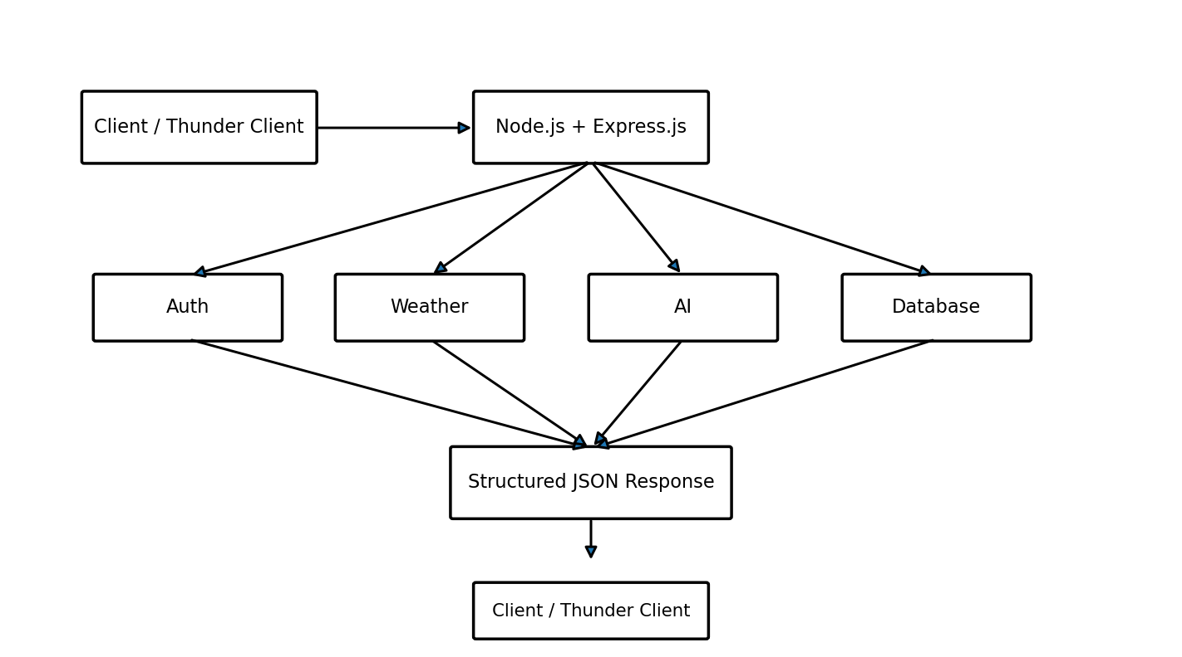
Figure 4.6 – Overall System Architecture and Data Flow

AI WeatherWise – Project Design | Team 07

